1. Business Context and Problem Definition
[Company Name] operates within the [industry sector] and provides [products/services] to [target users]. The organisation currently experiences challenges relating to [describe operational problem from scenario]. This results in [impact on service quality, accessibility, efficiency, or performance].
The organisation requires a digital solution to address these challenges and improve [key business objective]. The proposed system is a [type of system — e.g. web-based platform, mobile application, integrated digital service] designed to support [main system purpose].
This solution will improve operational efficiency by [benefit], enhance accessibility by [benefit], and support organisational growth by [benefit]. The system aligns with organisational goals relating to [goal from scenario].

2. User Groups and Stakeholders
The system will serve multiple user groups with distinct roles and needs.
Primary users include [User Group 1], who require the system to [primary function]. Secondary users include [User Group 2], who interact with the system to [purpose]. Professional or staff users such as [Staff Role] will use the system to [staff function], while administrative users will manage [administrative responsibilities].
Each group requires different levels of access, functionality, and support. The system must therefore provide appropriate permissions and features to ensure effective use.

3. User Personas
Persona 1 — [User Type]
Age: [ ]
Role: [ ]
Goals: [ ]
Challenges: [ ]
Technical ability: [ ]
Needs from system: [ ]
Persona 2 — [User Type]
Age: [ ]
Role: [ ]
Goals: [ ]
Challenges: [ ]
Technical ability: [ ]
Needs from system: [ ]
(Include at least 2 personas)
Purpose:
Personas represent realistic users to ensure design decisions are user-centred.

4. Empathy Maps
For key users, consider:
Says
[What users express or request]
Thinks
[User concerns, expectations]
Does
[Typical behaviour or actions]
Feels
[Emotions such as frustration, confusion, confidence]
This analysis informs accessibility, usability, and interface design decisions.

5. User Stories and Acceptance Criteria
As a [user role], I want to [function], so that [benefit].
Acceptance Criteria:
• The system must [measurable outcome]
• The system must [performance condition]
As a [user role], I want to [function], so that [benefit].
Acceptance Criteria:
• The system must [measurable outcome]
(Include at least 3–5 user stories)

6. Functional Requirements
The system must provide the following capabilities:
• The system must allow users to create and manage accounts.
• The system must enable [core feature].
• The system must store and process [data type].
• The system must allow communication between [user groups].
• The system must provide monitoring or reporting functionality.
• The system must allow administrative control of [system element].
Each function supports identified user needs and business objectives.

7. Non-Functional Requirements
The system must meet defined performance and quality standards:
Performance
• The system must respond within [time requirement].
Security
• Data must be protected using [security method].
Accessibility
• The system must support users with [accessibility needs].
Reliability
• The system must maintain [uptime level].
Compatibility
• The system must operate on [devices/platforms].
Maintainability
• The system must allow updates and maintenance.

KPI’s section 8
A KPI (Key Performance Indicator) is a specific and measurable goal that can be used to track the success of a project. I recommend that HAG uses the following:

Google reviews –
Third party websites are very important for business; this is because people who have visited the place leave reviews. The better the reviews the higher ranked you are the more you are seen by potential customers looking for medical information and tracking tools the more likely you are to be picked.

Customer satisfaction –
This help identify key areas for the business to improve on, therefor creating a better customer experience. This can be done by a survey where the customer is asked about their experience, what they liked the most and what could be improved upon. The industry standard for this is 77%, these also help the business identify places that are managed well. There are problems with this for example, customers might not take this seriously, filling out wrong information which effects the data given.

Risk assessment bookings-
If the amount of home risk assessment bookings increase, the more customers using the website. This indicates that the new features are liked by existing and new customers as the amount of booking increase.

Percentage of repeated customers –
Allows the business to see their ability to maintain their customers, meaning the new features that were recommended by existing users satisfy them. If the return rate is low, it makes it clear that the Charity must improve on the customer service, features and accessibility they offer. This can be calculated by adding the repeat customers + the new customers an * by 100.

Revenue and Profits –
Asses HAG financial performance if the profits are up the charity is getting new customer’s and maintaining the old ones.
Tracking these KPIs will allow the business to understand how the digital system is performing and make further improvements.
needs. These indicators provide measurable evidence of whether the system achieves its intended objectives and delivers practical value to [Company Name].

✅ SECTION 9 — Legal and Ethical Considerations (TABLE FORMAT)
Consideration | Description | How the System Addresses This | Why it is Important
Data Protection | Personal data must be stored and processed securely | Data encryption and secure access controls will be implemented | Protects user privacy and prevents data breaches
Privacy | Users must be informed about how their data is used | Privacy notice and clear data usage policies | Builds trust and transparency
Accessibility | System must be usable by a wide range of users | Accessible interface design and clear navigation | Ensures equal access to services
Intellectual Property | Digital content must be legally used | Only licensed or authorised content will be used | Prevents legal issues and protects ownership rights
Security Responsibility | Organisation must protect stored information | Authentication and permission controls will be applied | Prevents unauthorised access

✅ SECTION 10 — Risk Management (TABLE FORMAT)
Risk | Description | Likelihood | Impact | Mitigation Strategy
System Failure | The system may stop working or perform poorly | Medium | High | Regular maintenance and system monitoring
Data Breach | Unauthorised access to sensitive information | Low | High | Secure authentication and data protection measures
User Error | Users may misuse or incorrectly operate the system | Medium | Medium | Clear interface design and user guidance
Security Threat | Malicious attacks targeting the system | Low | High | Security controls and monitoring
Implementation Delay | System development may take longer than expected | Medium | Medium | Project planning and progress tracking

✅ SECTION 11 — System Decomposition
Pictures from website examples:

Non – functional

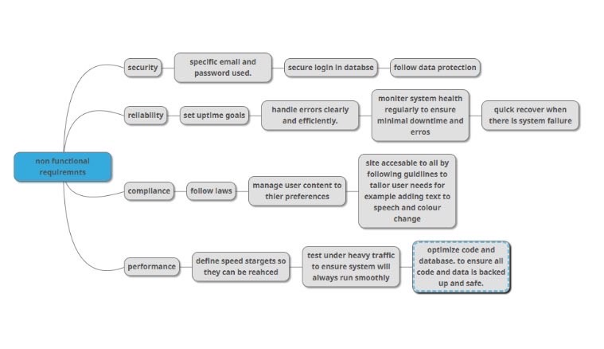
This is the breakdown of the non and functional requirements of this project, where most of the requirements are broken down into more detailed sections which are used to more easily understand each task.

Functional requirements

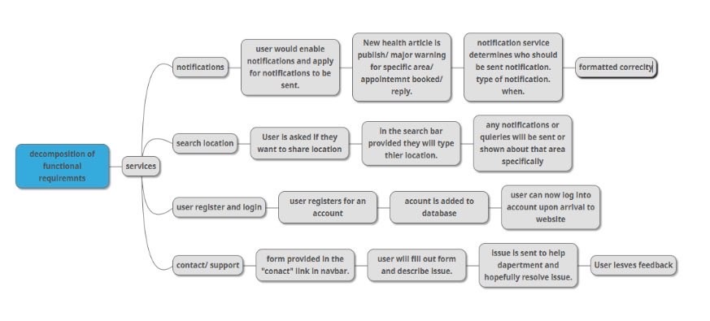

✅ SECTION 12 — Data Requirements
The system must manage several categories of data to support functionality and user interaction. This includes user account information, such as identification details and access credentials, which enable secure authentication and personalised access. Operational data relating to [service or activity] will be stored to support system processes and monitoring functions. Administrative data will be maintained to allow system management and oversight. All data will be structured and stored in a secure environment that prevents unauthorised access and ensures data integrity. Appropriate data handling practices will support system performance, protect user privacy, and ensure compliance with organisational and legal requirements. Effective data management is essential for enabling reliable system operation and supporting the needs of [Company Name] and its users.

Proposed Design
This proposal outlines a digital solution developed in response to the requirements of [COMPANY NAME]. The organisation is a [TYPE OF ORGANISATION — e.g. charity, business, service provider] that focuses on [MAIN PURPOSE / SERVICES PROVIDED]. The client has requested a digital system that improves user experience, enhances accessibility, and allows customers to access services more efficiently. The proposed solution will support features such as [FEATURE 1], [FEATURE 2], and [FEATURE 3], ensuring that both organisational and user needs are effectively met.
The digital platform will function as a central hub for users seeking [TYPE OF INFORMATION OR SERVICE]. It will provide clear and structured information about the organisation’s services, features, and updates, enabling users to make informed decisions. The system will also incorporate accessibility support, including [ACCESSIBILITY FEATURE — e.g. screen reader compatibility], [ACCESSIBILITY FEATURE], and [ACCESSIBILITY FEATURE], ensuring that individuals with diverse needs can interact with the system effectively.
The proposed solution includes new functionality based on client requirements and user research findings. Key features will include [FEATURE — e.g. booking system], [FEATURE — e.g. personalised dashboard], and [FEATURE — e.g. real-time data integration]. Users will be required to register or log in to access personalised services such as [PERSONALISED FEATURE] and [PERSONALISED FEATURE]. Authentication controls will ensure that user data is protected and that the system complies with data protection requirements.
Accessibility will be a central component of the system design. Based on feedback from stakeholders and users, the solution will include enhancements that support a wide range of user abilities. These improvements include [ACCESSIBILITY IMPROVEMENT — e.g. high contrast interface], [ACCESSIBILITY IMPROVEMENT], and [ACCESSIBILITY IMPROVEMENT]. These features ensure that the system promotes inclusivity and allows all users to interact with the platform without unnecessary barriers.
The system has been designed to meet the needs of multiple user groups. For general users, the platform will provide [USER FUNCTION — e.g. personalised services] and [USER FUNCTION]. For staff or authorised personnel, the system will enable [STAFF FUNCTION — e.g. content management], [STAFF FUNCTION], and [STAFF FUNCTION]. Administrative users will have access to system management tools that allow control over [ADMIN FUNCTION], ensuring the system remains secure, organised, and efficient.
Overall, the proposed digital solution integrates [CORE FEATURE], [CORE FEATURE], and [CORE FEATURE] into a unified platform. This approach improves operational efficiency, enhances user engagement, and provides a structured environment for delivering services. The system will modernise the organisation’s digital presence, support staff workflows, and create a more accessible and effective experience for all users.

